adding announcement cards to moodle
If you want a graphical element to call attention to information in a Moodle site, these ‘announcement cards’ can be a great way to do so. These cards will work in section descriptions, pages, and labels.

Getting Started
To add any of these elements to a Moodle site, you need to first turn on the html editor where you are working. Look for the html icon and click on it. Into the editor, copy and paste the code for the element you want. Click on the html icon again to return to the WYSIWYG (what you see is what you get) editor and update the text to suit your purposes.

Simple Announcement Cards
These cards can be edited to include text in the colored header, an accessible heading, and any text desired.

Simple Announcement with a Blue Outline and Header
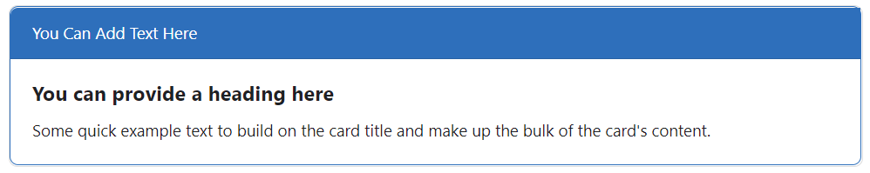

Copy and Paste this Code into the HTML Editor
<div class="card text mb-3 rounded"><span class="border border-primary border-5 rounded">
<div class="card-header bg-primary text-white">You Can Add Text Here</div>
<div class="card-body">
<h5 class="card-title">You can provide a heading here</h5>
<p class="card-text">Some quick example text to build on the card title and make up the bulk of the card's content. </p> </div></span></div><br>

Simple Announcement with a Turquoise Outline and Header
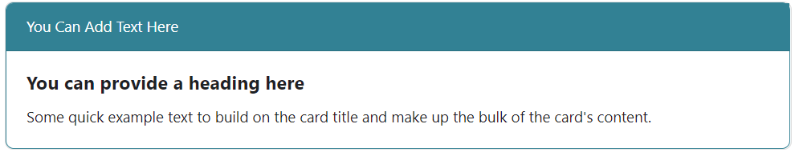

Copy and Paste this Code into the HTML Editor
<div class="card text mb-3 rounded"><span class="border border-info border-5 rounded">
<div class="card-header bg-info text-white">You Can Add Text Here</div>
<div class="card-body">
<h5 class="card-title">You can provide a heading here</h5>
<p class="card-text">Some quick example text to build on the card title and make up the bulk of the card's content. </p> </div> </span></div><br>

Simple Announcement with a Yellow Outline and Header
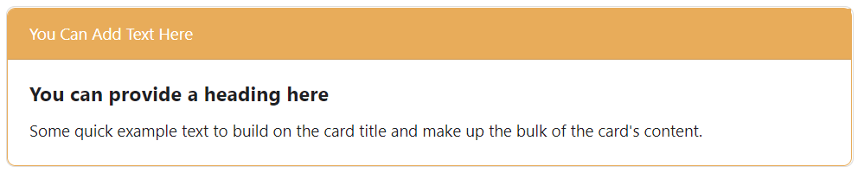

Copy and Paste this Code into the HTML Editor
<div class="card text mb-3 rounded"><span class="border border-warning border-5 rounded">
<div class="card-header bg-warning text-white">You Can Add Text Here</div>
<div class="card-body">
<h5 class="card-title rounded">You can provide a heading here</h5>
<p class="card-text">Some quick example text to build on the card title and make up the bulk of the card's content. </p> </div></span></div><br>

Simple Announcement with a Red Outline and Header
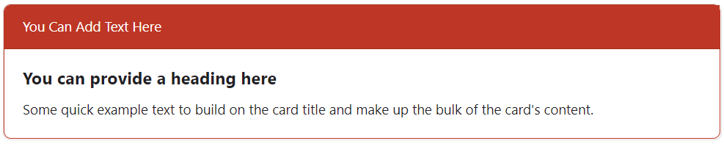

Copy and Paste this Code into the HTML Editor
<div class="card text mb-3 rounded"><span class="border border-danger border-5 rounded">
<div class="card-header bg-danger text-white">You Can Add Text Here</div>
<div class="card-body">
<h5 class="card-title rounded">You can provide a heading here</h5>
<p class="card-text">Some quick example text to build on the card title and make up the bulk of the card's content. </p> </div></span></div><br>

Simple Announcement with a Black Outline and Header
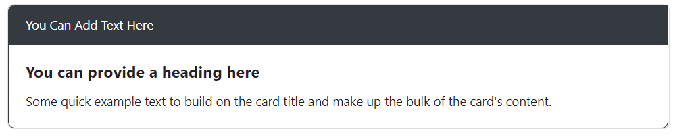

Copy and Paste this Code into the HTML Editor
<div class="card text mb-3 rounded"><span class="border border-dark border-5 rounded">
<div class="card-header bg-dark text-white">You Can Add Text Here</div>
<div class="card-body">
<h5 class="card-title rounded">You can provide a heading here</h5>
<p class="card-text">Some quick example text to build on the card title and make up the bulk of the card's content. </p></div></span></div><br>

Simple Announcement with a Green Outline and Header
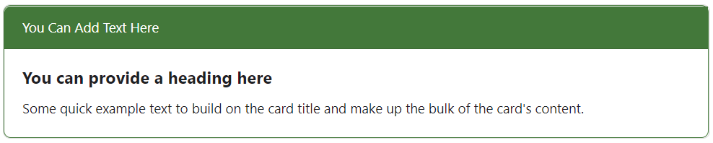
<div class="card text mb-3 rounded"><span class="border border-success border-5 rounded">
<div class="card-header bg-success text-white">You Can Add Text Here</div>
<div class="card-body">
<h5 class="card-title rounded">You can provide a heading here</h5>
<p class="card-text">Some quick example text to build on the card title and make up the bulk of the card's content. </p></div></span></div><br>

Simple Announcement with a Gray Outline and Header
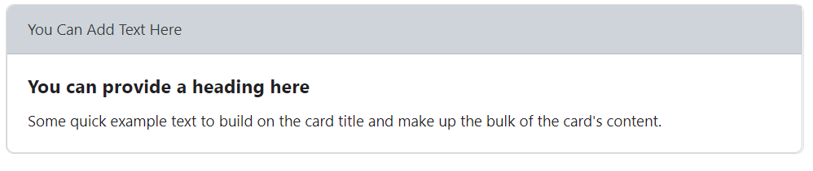

Copy and Paste this code into the HTML Editor
<div class="card text mb-3 rounded"><span class="border border-secondary border-5 rounded">
<div class="card-header bg-secondary text-dark">You Can Add Text Here</div>
<div class="card-body">
<h5 class="card-title rounded">You can provide a heading here</h5>
<p class="card-text">Some quick example text to build on the card title and make up the bulk of the card's content. </p></div> </span></div><br>

Announcement Box with Bullet Points
It is also possible to create announcement cards with bullet points. Just copy the appropriate code and place it in the html editor then return to the WYSIWYG editor to input the text you wish.

Bulleted Announcement with a Blue Outline and Header
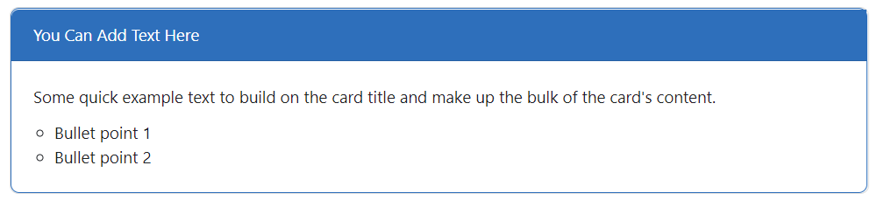

Copy and Paste this Code into the HTML Editor
<div class="card text mb-3 rounded"><span class="border border-primary border-5 rounded">
<div class="card-header bg-primary text-white">You Can Add Text Here</div>
<div class="card-body">
<h5 class="card-title"><span style="font-size: 0.9375rem; font-weight: 400;">Some quick example text to build on the card title and make up the bulk of the card's content. </span></h5>
<ul>
<li><span style="font-size: 0.9375rem; font-weight: 400;">Bullet point 1</span></li>
<li><span style="font-size: 0.9375rem; font-weight: 400;">Bullet point 2</span></li>
</ul>
</div> </span></div><br>

Bulleted Announcement with a Turquoise Outline and Header
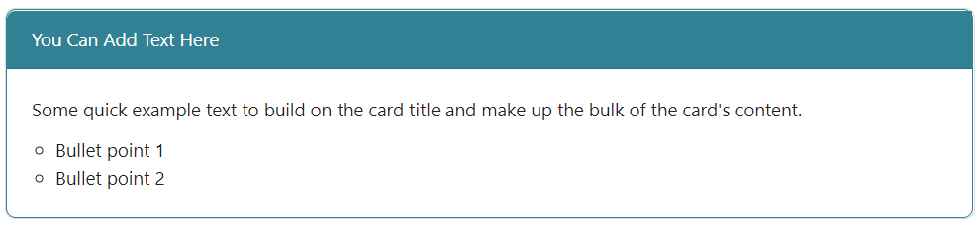

Copy and Paste this code into the HTML Editor
<div class="card text mb-3 rounded"><span class="border border-info border-5 rounded">
<div class="card-header bg-info text-white">You Can Add Text Here</div>
<div class="card-body">
<h5 class="card-title"><span style="font-size: 0.9375rem; font-weight: 400;">Some quick example text to build on the card title and make up the bulk of the card's content. </span></h5>
<ul>
<li><span style="font-size: 0.9375rem; font-weight: 400;">Bullet point 1</span></li>
<li><span style="font-size: 0.9375rem; font-weight: 400;">Bullet point 2</span></li>
</ul>
</div> </span></div><br>

Bulleted Announcement with a Yellow Outline and Header
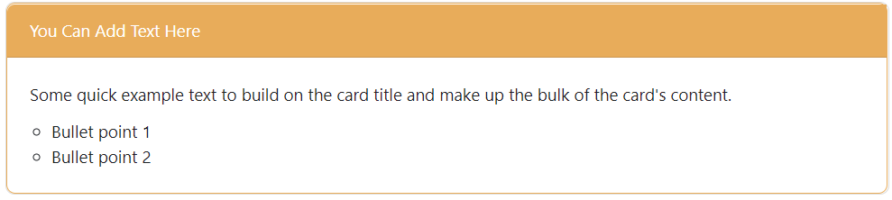

Copy and Paste this code into the HTML Editor
<div class="card text mb-3 rounded"><span class="border border-warning border-5 rounded">
<div class="card-header bg-warning text-white">You Can Add Text Here</div>
<div class="card-body">
<h5 class="card-title"><span style="font-size: 0.9375rem; font-weight: 400;">Some quick example text to build on the card title and make up the bulk of the card's content. </span></h5>
<ul>
<li><span style="font-size: 0.9375rem; font-weight: 400;">Bullet point 1</span></li>
<li><span style="font-size: 0.9375rem; font-weight: 400;">Bullet point 2</span></li>
</ul>
</div> </span></div><br>

Bulleted Announcement with a Red Outline and Header
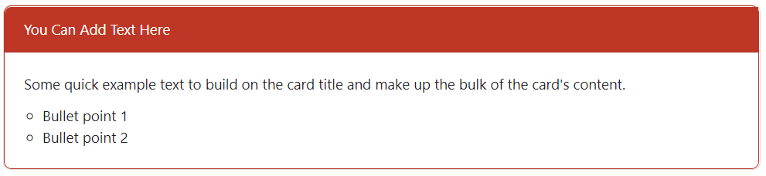

Copy and Paste this code into the HTML Editor
<div class="card text mb-3 rounded"><span class="border border-danger border-5 rounded">
<div class="card-header bg-danger text-white">You Can Add Text Here</div>
<div class="card-body">
<h5 class="card-title"><span style="font-size: 0.9375rem; font-weight: 400;">Some quick example text to build on the card title and make up the bulk of the card's content. </span></h5>
<ul>
<li><span style="font-size: 0.9375rem; font-weight: 400;">Bullet point 1</span></li>
<li><span style="font-size: 0.9375rem; font-weight: 400;">Bullet point 2</span></li>
</ul>
</div> </span></div><br>

Bulleted Announcement with a Black Outline and Header
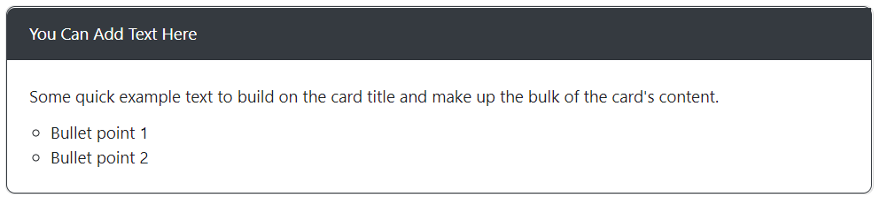

Copy and Paste this code into the HTML Editor
<div class="card text mb-3 rounded"><span class="border border-dark border-5 rounded">
<div class="card-header bg-dark text-white">You Can Add Text Here</div>
<div class="card-body">
<h5 class="card-title"><span style="font-size: 0.9375rem; font-weight: 400;">Some quick example text to build on the card title and make up the bulk of the card's content. </span></h5>
<ul>
<li><span style="font-size: 0.9375rem; font-weight: 400;">Bullet point 1</span></li>
<li><span style="font-size: 0.9375rem; font-weight: 400;">Bullet point 2</span></li>
</ul>
</div> </span></div><br>

Bulleted Announcement with a Green Outline and Header
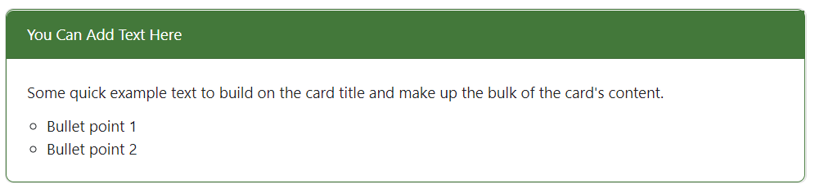

Copy and Paste this code into the HTML Editor
<div class="card text mb-3 rounded"><span class="border border-success border-5 rounded">
<div class="card-header bg-success text-white">You Can Add Text Here</div>
<div class="card-body">
<h5 class="card-title"><span style="font-size: 0.9375rem; font-weight: 400;">Some quick example text to build on the card title and make up the bulk of the card's content. </span></h5>
<ul>
<li><span style="font-size: 0.9375rem; font-weight: 400;">Bullet point 1</span></li>
<li><span style="font-size: 0.9375rem; font-weight: 400;">Bullet point 2</span></li>
</ul>
</div> </span></div><br>

Bulleted Announcement with a Gray Outline and Header
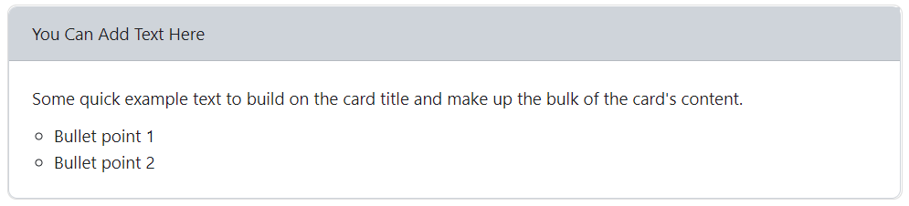

Copy and Paste this code into the HTML Editor
<div class="card text mb-3 rounded"><span class="border border-secondary border-5 rounded">
<div class="card-header bg-secondary text-dark">You Can Add Text Here</div>
<div class="card-body">
<h5 class="card-title"><span style="font-size: 0.9375rem; font-weight: 400;">Some quick example text to build on the card title and make up the bulk of the card's content. </span></h5>
<ul>
<li><span style="font-size: 0.9375rem; font-weight: 400;">Bullet point 1</span></li>
<li><span style="font-size: 0.9375rem; font-weight: 400;">Bullet point 2</span></li>
</ul>
</div> </span></div><br>

