faculty contact information boxes
Making faculty contact information easily accessible on Moodle, rather than having students refer back to the syllabus, can facilitate and even encourage to contact faculty when they have questions or problems. The html code can help faculty create an easily identifiable container for their contact information on Moodle.
To maintain the formatting of these boxes, it’s important to complete some steps differently and a bit more carefully than usual.

Getting Started
To add any of these elements to a Moodle site, you need to first turn on the html editor where you are working. Look for the html icon and click on it. Into the editor, copy and paste the code for the element you want. Click on the html icon again to return to the WYSIWYG (what you see is what you get) editor and update the text to suit your purposes.

Types of Faculty Information Boxes
Using the code and directions provided in this tip sheet, you can create the following faculty information boxes for any Moodle course site:
- A horizontal, five-line box that includes a picture; this box is best suited to add to Moodle’s top “General” section of the course.
- A horizontal, four-line box that includes a picture; this box is best suited to add to Moodle’s top “General” section of the course.
- A faculty contact information Block, which includes a picture, that can be added to a course’s block drawer configuration.

Important Editing Information

Making the Sure the Email Address Link Works Correctly
Because creating an operable email link takes special html code, make sure to edit the email address before returning to the WYSIWYG editor. Look for two instances of the email address to change. The first will be preceded by href= while the other will be preceded by target=”_blank”>. Make sure to update both instances to your own email address.
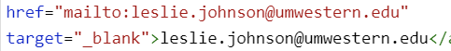

Changing the Picture without Encountering Problems
Important recommendation: Select an image that is cropped square.
After pasting in the code and returning to the WSIWYG editor, you will notice that the picture is now a broken image link icon. Click on the icon to highlight it; then click on the photo icon in the Moodle editing tools. Locate and upload the picture you wish to use, making sure to set the image size to 300 x300 and add a description.
You will notice that Moodle eliminated the rounded corners on the images. If you want those rounded corners back, here’s what to do:
- Open the HTML editor.
- Look the text atto_image_button_text-bottom. Hint: On your keyboard press the ctrl and f keys (the command and f keys on a Mac). In the box that appears, type “atto” and the browser will highlight the place you’re looking for.
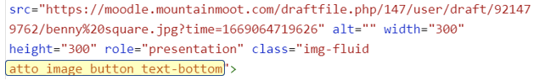
- Change atto_image_button_text-bottom to rounded. Be careful not to erase any quotation marks in doing so.
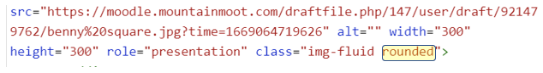
- Click Save changes.

Five-Line Contact Information Box for General Moodle Section
These cards can be added to the top or “General” Moodle section and create an easily recognizable location for faculty contact information.
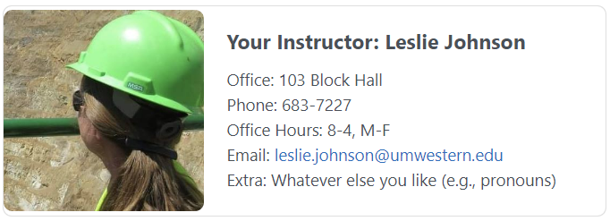

Copy and Paste this Code into the HTML Editor
<br><div class="card mb-3 d-flex align-items-center" style="max-width: 540px;">
<div class="row no-gutters">
<div class="col-md-4 d-flex align-items-center">
<img class="img-fluid rounded" src="https://moodle.mountainmoot.com/draftfile.php/147/user/draft/112055647/zoom%20profile%20%282%29.jpg">
</div>
<div class="col-md-8 d-flex align-items-center">
<div class="card-body">
<h5 class="card-title">Your Instructor: Leslie Johnson</h5>
<p class="card-text">
Office: 103 Block Hall<br>
Phone: 683-7227<br>
Office Hours: 8-4, M-F<br>
Email: <a href="mailto:leslie.johnson@umwestern.edu" target="_blank">leslie.johnson@umwestern.edu</a><br>
Extra: Whatever else you like (e.g., pronouns)<br>
</p> </div></div></div></div><br>

Reminders about Changing the Text and the Image
Remember to ensure the email address and image are formatted correctly:
- Make sure that both the text and the link work to send you an email.
- The image appears correctly and is formatted how you wish.

Four-Line Contact Information Box for General Moodle Section
These cards can be added to the top or “General” Moodle section and create an easily recognizable location for faculty contact information.
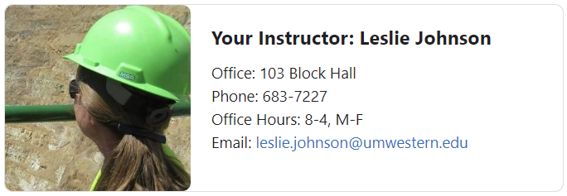

Copy and Paste this Code into the HTML Editor
<br><div class="card mb-3 d-flex align-items-center" style="max-width: 540px;">
<div class="row no-gutters">
<div class="col-md-4 d-flex align-items-center">
<img class="img-fluid rounded" src="https://moodle.mountainmoot.com/draftfile.php/147/user/draft/112055647/zoom%20profile%20%282%29.jpg">
</div>
<div class="col-md-8 d-flex align-items-center">
<div class="card-body">
<h5 class="card-title">Your Instructor: Leslie Johnson</h5>
<p class="card-text">
Office: 103 Block Hall<br>
Phone: 683-7227<br>
Office Hours: 8-4, M-F<br>
Email: <a href="mailto:leslie.johnson@umwestern.edu" target="_blank">leslie.johnson@umwestern.edu</a><br>
</p> </div></div></div></div><br>

Reminders about Changing the Text and the Image
Remember to ensure the email address and image are formatted correctly:
- Make sure that both the text and the link work to send you an email.
- The image appears correctly and is formatted how you wish.

Contact Information for a Text Block
Moodle allows teachers to add custom-created “Text Blocks” to a course’s block drawer. Faculty can create a Text Block that can provide a quick reference for faculty contact information.
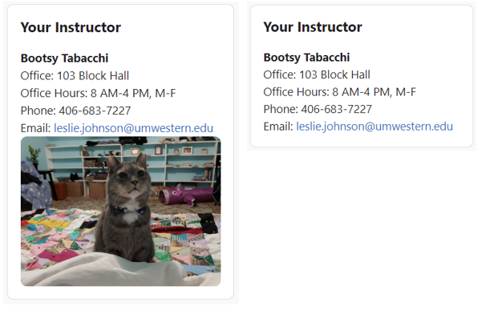

Create the Text Block
On the main page of your course, turn on Edit mode then expand the block drawer. Click on + Add a block then select Text from the Add a block menu.
When the new block appears, open its dropdown menu and select Configure (new text block) block. Give your block a title where asked. Before creating the block’s content, open the Where this block appears menu. From the Display on page types, you want to designate where the block will appear within your course. If you wish the block to appear on every page, select Any page; if you only want the block to appear on the main page, leave this setting at the default.
Now, turn on the HTML editor for the Content creation area then copy and paste the code below to create your desired block.

Code for a Block without an Image
<strong>Bootsy Tabacchi</strong><br>Office: 103 Block Hall<br>Office Hours: 8 AM-4 PM, M-F<br>Phone: 406-683-7227<br>Email:&nbsp;<a href="mailto:leslie.johnson@umwestern.edu" target="_blank">leslie.johnson@umwestern.edu</a><br>

Code for a Block with an Image
<strong>Bootsy Tabacchi</strong><br>Office: 103 Block Hall<br>Office Hours: 8 AM-4 PM, M-F<br>Phone: 406-683-7227<br>Email:&nbsp;<a href="mailto:leslie.johnson@umwestern.edu" target="_blank">leslie.johnson@umwestern.edu</a><br><img src="https://moodle.mountainmoot.com/draftfile.php/147/user/draft/545853843/0106222104.jpg" class="img-fluid rounded">

Reminders about Changing the Text and the Image
Remember to ensure the email address and image are formatted correctly:
- Make sure that both the text and the link work to send you an email.
- The image appears correctly and is formatted how you wish.

Need Something Else?
If you need special design elements created for your course, let eLearning know by completing our Instructional Design Request Form.

